INFSCI 2725 Data Analytics

Assignment 3: Validation and Testing

Fengxi Liu, Jinrong Liu

1. Overall classification accuracy.



1. Sensitivity and specificity for each of the two parties.

Firstly, we get a confusion matrix from the result of validation as follows:

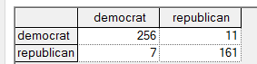

We can get conclusions from this matrix:





1. Positive and negative predictive value for each of the two parties.

We can also get this from the confusion matrix





1. Calibration curve for a selected bin count or window size.

Algorithm: Binning Selected Bin count is : 10 (default)

We can draw the two Calibration curves of two parties:

